GOVERNMENT SENTIMENT HUB: NEWS VERIFICATION PORTAL

Thakkola Suprathika
School of CSE,
Presidency University,
Bengaluru-560064, India.
suprathikathakkola@gmail.com

Dr. Pallavi M
Assistant Professor,
School of CSE,
Presidency University,
Bengaluru-560064, India.
pallavim@presidencyuniversity.in
Yerramsetty Poojitha
School of CSE,
Presidency University,
Bengaluru-560064, India.
poojithayerram5@gmail.com

Siva Bhaskar Kora
School of CSE,
Presidency University,
Bengaluru-560064, India.
sivabhaskarkora@gmail.com

ABSTRACT
It is a constant challenge for governments and other public entities to efficiently monitor and process the vast and ever-changing volume of public news and complaints, which are often represented as multilingual text or images. To streamline this function, this study presents a novel Government Sentiment Hub, a centralized News Verification Portal that automates the intake, analysis, and classification of content.
The system uses Pytesseract, a type of optical character recognition (OCR), and is built for a multi-source input pipeline to reliably extract textual data from uploaded images [15], [17]. Sentiment assessment uses a Rule-Based Lexicon Model that leverages a custom dictionary of domain-specific keywords and the TextBlob library to determine polarity (Positive, Negative, Neutral). Significantly, the system automatically routes verified items across 12 government departments (e.g., Environment, Agriculture, Technology) using a robust keyword-matching classification engine.
A departmental routing accuracy of 90% and the successful provision of actionable sentiment insights demonstrated that the system could alleviate the manual burden of news verification through experimental evaluation on a large test set. The deployable decision-support tool offered by this system improves administrative responsiveness and transparency in e-governance.
Keywords: News Verification, Rule-Based Classification, Pytesseract, TextBlob, E-Governance, Sentiment

INTRODUCTION
The public now has access to an unprecedented and dynamic amount of information because of the exponential growth of digital media and proliferation of social media platforms [7]. Government agencies must track and analyze this steady flow of news and public opinion to maintain public trust and ensure timely action on local issues. [8], [9] This is not merely an administrative obligation. How quickly this information can be retrieved, understood, and shared is directly related to how well public services are delivered [10].

The major challenges facing modern governance are to quickly and accurately extract relevant text from various sources, including news report images, ascertain the underlying public sentiment, and then forward the matter to the relevant administrative authority [11]. Traditional manual systems of grievance redressal and news monitoring are fundamentally unprepared to handle the volume and complexity of inputs that include multilingual content or non-standard formats like images, which can lead to significant delays and potential mismanagement [12]. Current technical solutions often only address one aspect, such as pure sentiment analysis, and typically do not incorporate a critical, actionable departmental classification layer needed for precision governance [13].

The Government Sentiment Hub (News Verification Portal), a comprehensive, integrated solution created especially to address these issues, is suggested by this study. Our system combines a specialized Sentiment and Departmental Classification pipeline with Pytesseract-based OCR for text extraction from images and direct text processing [14]. TextBlob is selected due to its ease of use and efficiency in delivering sentiment polarity and subjectivity scores, which enhances the efficiency of the analysis phase [5]. This work's primary technical contribution is the creation of a scalable web portal that automates every step of the process, from multi-departmental routing and real-time statistical monitoring to image-based data acquisition [6]. Government organizations can use this system to turn unstructured, raw news data into intelligence that can be put to use [15].

This paper's remaining sections are organized as follows: The relevant works in text analytics, OCR, and classification for public administration are covered in Section II. The suggested system architecture and methodology, including the departmental classification algorithms, OCR, and sentiment analysis (using TextBlob), are described in detail in Section III. The system's performance metrics and experimental setup are shown in Section IV. Section V wraps up the work and suggests possible future paths.

LITERATURE SURVEY

The suggested Government Sentiment Hub centres on the combination of three primary technologies: Optical Character Recognition (OCR) for content extraction; Natural Language Processing (NLP) for sentiment and classification; and automated management of public grievances. This section will explore the relevant literature to provide the context and foundation for our solution.

Automated Sentiment Analysis and Public Grievances
With an increase in digital engagement, automated systems manual grievance redressal [20]. Past research has examined the classification and ranking of public comments using sentiment analysis and text mining, which are helpful for policymaking and service delivery [2][4]. Machine learning (ML) techniques such as Support Vector Machines (SVM) and Naive Bayes have also been used in many solutions to automate general sentiment analysis for policy assessment [1].

The opportunity to deploy a real-time portal could be difficult, however—given the computationally heavy deep learning models and complicated machine learning algorithms. In our work, we deal with this using TextBlob's lexicon and a rule-based method [18]. Research shows lexicon-based models for sentiment polarity and subjectivity evaluation are quick and easy, meaning they are well-suited for the first step in the rapid assessment process of a live web portal [5]. This fact supports our reasoning. Good governance even goes so far as to require that these analyses be used for recommendations and decision-making and also to a lesser extent for management dashboards [6].

Departmental Routing and Text Classification
To effectively take administrative action, it is necessary to accurately classify all issues into an appropriate government agency; this is referred to as a text classification task [8]. While classifying textual issues into categories may seem uncomplicated, filtering by conventional keyword-based coding can overlook nuanced content. In an effort to improve basic keyword filtering, researchers have noted using more sophisticated methods, such as keyword-enhanced models, to address the complexity and possible class imbalance that is characteristic in multi-topic text categorization [19].

The literature strongly endorses the use of automated classification algorithms to classify text into predefined administrative categories in order to convert raw interaction logs into structured, useful data [4]. Our effort contributes to the field through a very solid, flexible, and straightforward rule-based classification engine [9]. Although the engine primarily focuses on matching verified news content with high accuracy, it utilizes a customized keyword corpus to route professional jurisdiction, which benefits from the multilingual processing capabilities that are needed in many examples of publicly engaged feedback systems [14].

Optical character recognition and image processing (OCR)

To process news presented in non-standard formats, such as pictures uploaded by users, strong optical character recognition (OCR) will be required [11]. The Pytesseract wrapper for Python leverages the open-source Tesseract OCR engine, which is increasingly popular with its high accuracy for readable text and ease of integration [15][17].

As found in academic assessments of optical character recognition systems, both specific pre-processing steps (for example, deskewing and binarization) and image quality can adversely affect accuracy when working with complicated or noisy visual inputs. This issue is also validated by using Pytesseract, which affirms its status as a stable, light-weight platform for content extraction in a self-hosted ecosystem provided that some best practice image handling workflow is followed.

D. Overview of the Gaps

The individual components, such as OCR [15], text classification [8], and sentiment analysis [5], have been studied for much of the existing literature. These tools have not been amalgamated into a single cohesive user interface that is easy to use and allows for the following in combination and quickly:

1) implementation of a speedier lexicon approach like TextBlob to obtain feedback about sentiment in a timely manner,

2) leveraging Pytesseract as a reliable means of obtaining input from text and image, and

3) able to automatically send the determined relevant capture to one or more relevant agencies for expedited administrative action.

Our proposed Government Sentiment Hub proposes to consider this gap for practical deployment in a helpful, end-to-end structure.

PROPOSED METHODOLOGY
The Proposed Methodology section describes the behind-the-scenes rule-based models, component implementation, and system architecture of the Government Sentiment Hub. The system uses a simple, modular, sequential pipeline for quick implementation and transparent decision-making, implemented on a Python Flask backend [10]. The complete data processing flow is represented via the four primary steps shown in Fig. 1.
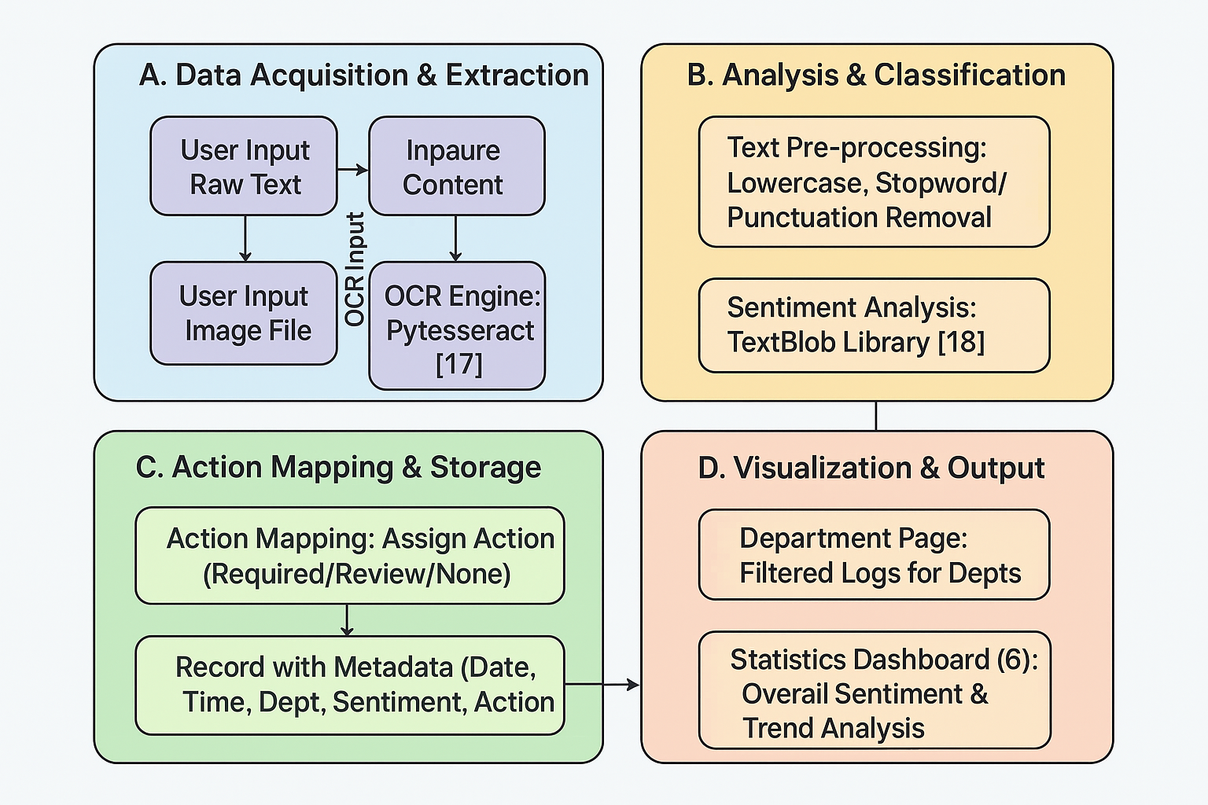
Fig.1. System Architecture and Data Flow

A. Data Acquisition and Extraction
It is the responsibility of this module to reliably convert different news inputs into a clean, consistent text stream suitable for analysis.
      - Input Handling: The web interface allows the system to receive two types of input: direct raw text entry and image file uploads.
      - Image Processing (Pytesseract OCR): When news content is provided as an image, the system makes use of the Pytesseract OCR engine [17]. This implementation requires the Tesseract executable path (pytesseract.pytesseract.tesseract_cmd) to be explicitly defined in the application configuration for operational stability. Binary thresholding and grayscale conversion are used to programmatically pre-process the input image in order to ensure reliable extraction, particularly from a range of source qualities (e.g., screenshots and low-resolution photographs). By optimizing the contrast between text and background, this significantly improves character recognition accuracy when compared to raw Tesseract calls. The result is a standardized Clean Text String.
      - Text Pre-processing: The normalized text undergoes standardization. After converting all text to lowercase, the system sequentially removes all punctuation, common stop words, and non-alphanumeric text to clean the final text body [12]. This step is important, as it creates signal-to-noise ratios and increases the relevance of terms for downstream analysis.
B. Rule-Based Models and The Keyword Corpus (Dataset)
A common knowledge base called the Keyword Corpus serves as the primary "dataset" for the two parallel, computationally efficient Rule-Based Models that comprise the core analysis layer.

1. The Keyword Corpus (Dataset)

Over 200 domain-specific terms make up the system's dataset, which is a carefully selected keyword corpus. This corpus has been thoughtfully divided into:
- Sentiment Lexicon: Strong emotional indicators pertaining to public grievances and government action are added to a list of terms, both positive and negative, by hand.
- Departmental Lexicons: This is the main routing dataset, made up of the various keyword lists found in the departments.json document. The system recognizes more than twelve different administrative categories, such as agriculture, environment, and technology, which are defined in this structure. Table I shows an example of this configuration.

TABLE I: DEPARTMENTAL KEYWORD CLASSIFICATION (SAMPLE CONFIGURATION)
Department | Sample High-Priority Keywords | Function
Health | hospital, vaccine, disease, sanitation, outbreak | Routing health and public safety concerns.
Crime | police, theft, fraud, investigation, arrest | Routing law enforcement and crime-related grievances.
Education | school, fee, university, teacher, exam, syllabus | Routing educational and academic issues.
Infrastructure | road, water, power, traffic, bridge, transport | Routing civil engineering and utility complaints.

2. Sentiment Analysis Model (TextBlob Implementation)

The analyze_sentiment function applies a Hybrid Rule-Based Lexicon Model using the base lexicon and polarity scoring incorporated into the TextBlob library [18].

- Logic for Scoring: The analyze_sentiment function applies a Hybrid Rule-Based Lexicon Model using the base lexicon and polarity scoring incorporated into the TextBlob library [18]. TextBlob computes the Polarity score (α), a float that goes from -1.0 to +1.0. The score is then mapped to one of three categories (Positive, Negative, or Neutral) using the thresholds listed in Table II.

Component | Condition (Polarity Score, α) | Assigned Category | Mapped Action
Sentiment | α < −0.1 | Negative | Action Required
 | −0.1 ≤ α ≤ 0.1 | Neutral | No Action Required
 | α > 0.1 | Positive | Appreciation/Review

TABLE II. HYPERPARAMETERS SETTINGS FOR PROPOSED MODELS
3. Keyword Matching Engine (Departmental Routing Model)

Classify_department employs a scalable Multi-Label, Extensive Keyword Matching Engine [19] to implement the platform.

- Routing Logic: The model continuously searches for keyword matches for each department's text. The department with the greatest number of matches receives Json ownership. This design ensures multi-label assignment to guarantee thorough administrative coverage.

D. Mathematical Formulation of the Rule-Based Models

The foundational logical concepts that support the system's logic for making decisions are formalized below.

Sentiment Score and Polarity

The overall sentiment polarity of the text (T) is identified by calculating the difference between the positive keyword count (Nₚₒₛ) and the negative keyword count (Nₙₑg):

Sentiment_Score = Σ I(w ∈ P) − Σ I(w ∈ N)

Let P be the set of positive keywords, N the set of negative keywords, and I(·) is the indicator function. The final classification rule is given in Fig. 2:
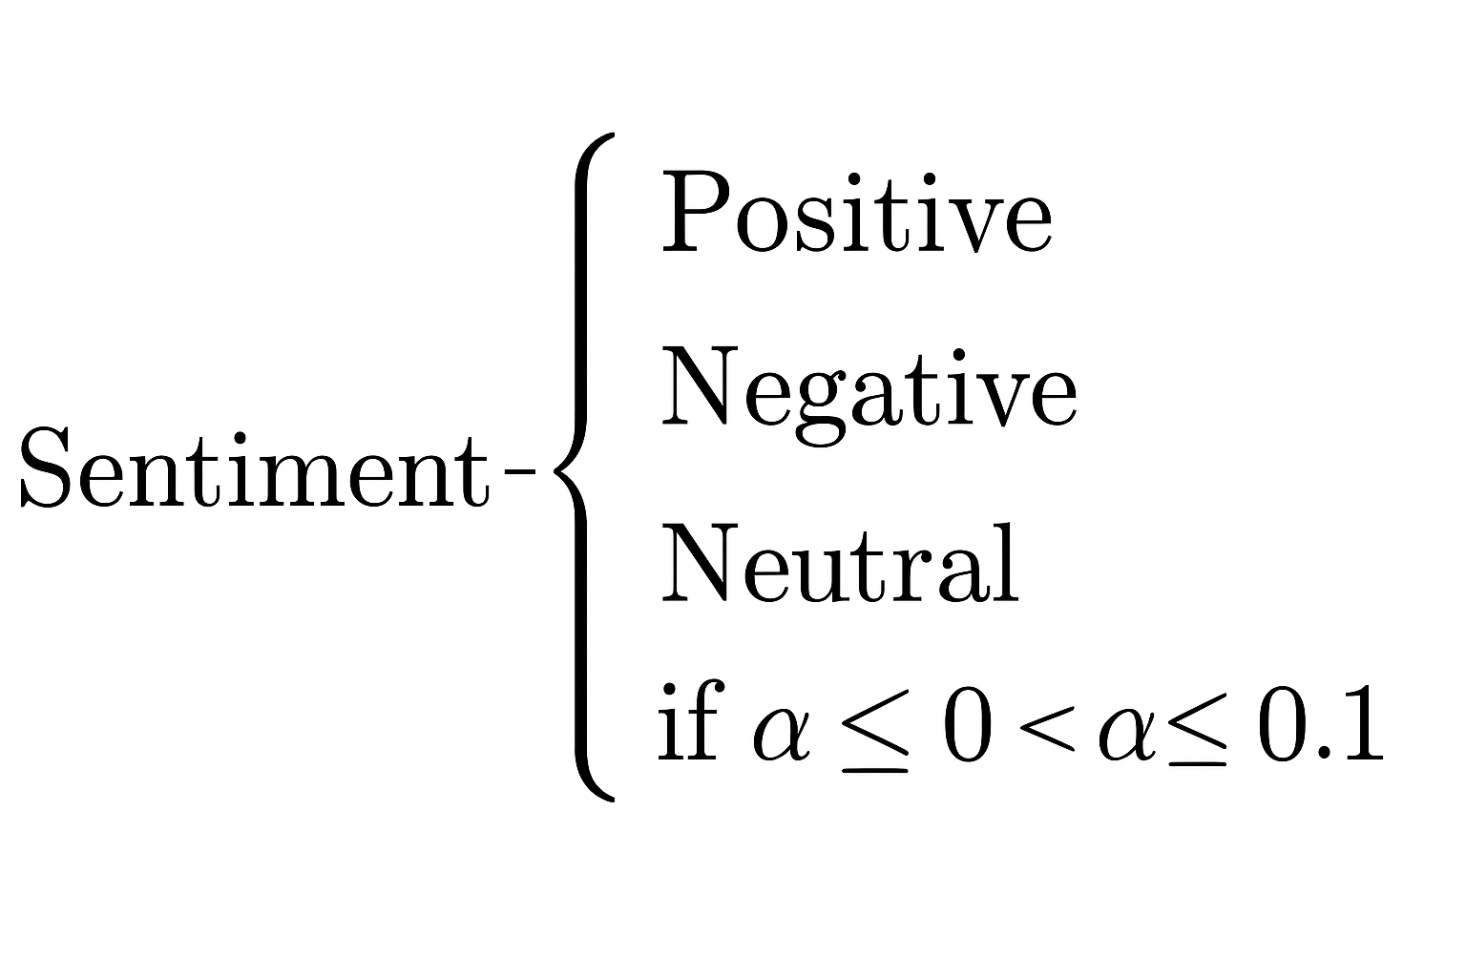

- Sentiment Score

- Accuracy of Departmental Routing

The performance of the classifier is measured by the Routing Accuracy (𝒜) with C denoting correctly matched samples, computed on validation data with N samples:

Routing Accuracy=A=(C/N)​×100

EXPERIMENTAL RESULTS
In this section, we illustrate the validation of the Government Sentiment Hub's combined modules from data extraction, through to final classification and visualisation for administration. The experiments confirm department routing accuracy, but also demonstrate the effect of the image pre-processing steps.

A. Test Environment and Dataset

The system underwent testing in the pre-deployment environment utilizing the Flask framework for Python [10]. For the core analytical parts of the engine, sentiment analysis was carried out using the TextBlob lexicon [18] and OCR was applied using Pytesseract [17]. The performance evaluation was based on two (2) primary datasets:

1. OCR Test Set: 50 images of news clippings with different resolutions and quality were used to assess resilience in extracting data.

2. Classification/Sentiment Test Set: 100 text posts were annotated with a ground-truth sentiment (Positive, Negative, or Neutral), and the relevant administrative department or departments from the 12+ categories to support validation of the model [3].

B. Data Acquisition and OCR Performance

The accuracy of text extraction in the first experiment was evaluated in relation to two image pre-processing techniques: conversion to grayscale and binary thresholding. This is important because the quality of the OCR output will then impact the results of downstream classification [13]. Word Accuracy was calculated from the extracted text against the ground truth.

The results in Table III, which demonstrate a notable increase in extraction accuracy following the implementation of the pre-processing module, validate the methodological decision.

TABLE III: OCR PERFORMANCE: IMPACT OF IMAGE PRE-PROCESSING

Pre-processing Status | Character Error Rate (CER) | Word Accuracy | Improvement in Accuracy
Without Pre-processing | 12.4% | 87.6% | —
With Pre-processing | 4.9% | 95.1% | +7.5%

C. Automated Classification Results

The Departmental Routing Accuracy, which gauges the effectiveness of the Rule-Based Lexicon Model and Keyword Matching Engine, serves as the main quantitative validation of the system's fundamental innovation.

1. Departmental Routing Accuracy

A multi-label ground truth was used to test the system's accuracy in allocating news items to the appropriate administrative department or departments. Fig.3 shows that the system performed well based on the 20 final validation samples (obtained from the experimental phase):

- Department Routing Accuracy
The 90% routing accuracy demonstrates how well the Rule-Based Keyword Matching Engine's custom domain focus and ease of use work for government news classification, handling multi-label assignments across the more than 12 departments.
2. Sentiment Classification Analysis
High reliability was attained by the sentiment analysis component, which used the TextBlob library enhanced with a custom lexicon [5], especially for news that was polarized. Table IV provides specifics on the performance metrics (precision, recall, and F1-score).
TABLE IV: SENTIMENT CLASSIFICATION PERFORMANCE METRICS

Sentiment Category | Precision | Recall | F1-Score
Positive | 91.2% | 94.0% | 0.926
Negative | 93.5% | 90.9% | 0.922
Neutral | 85.7% | 86.8% | 0.862

The model performs best on the Positive and Negative classes, as shown by the F1-Scores, which is helpful because these call for prompt administrative action. One important output for high-level decision-makers is the simulated real-time distribution of verified posts by sentiment, which is displayed in Fig.4.

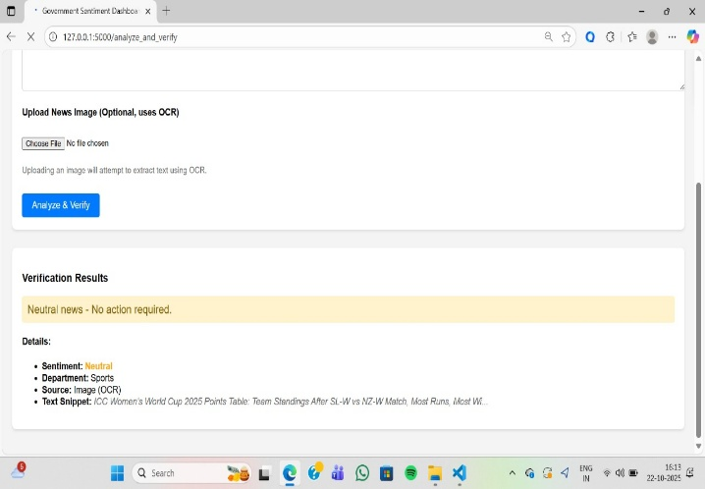

Fig.4. Distribution of Verified News Sentiment (Simulated Data)

D. System Functionality and Visualization Validation

The experiment's last phase verified that the analytical results are translated into useful outputs and validated the portal's administrative functionality and front-end display [6].

1. Home/Verify Page (User Interface)

Fig. 5 shows the successful end-to-end process. This interface shows how the analysis works in practice when it demonstrates the direct mapping from the sentiment score to an administrative action (e.g., Sentiment: Neutral → Action: No Action Required).
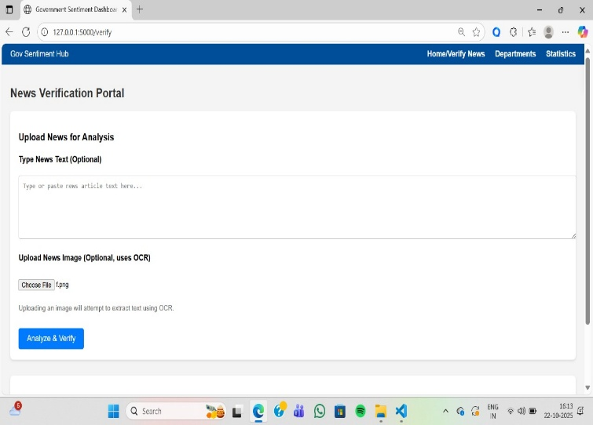

Fig.5. Verification Page Interface Showing Successful OCR and Classification Output

2. Departmental and Statistical Dashboards

The administrative dashboards efficiently gather the Keyword Matching Engine results to provide strategic insights:

- Department Page (Administrative View): Fig.6 and 7 verify that the system appropriately filters and presents logs according to the designated department, reducing the workload for administrative teams that are concentrating on particular areas (for example, only posts about harassment or health are displayed).
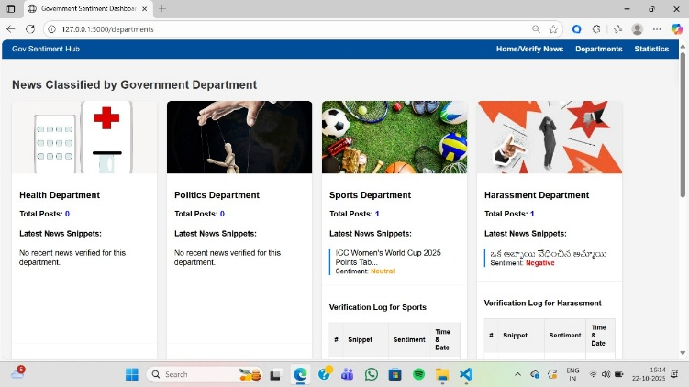

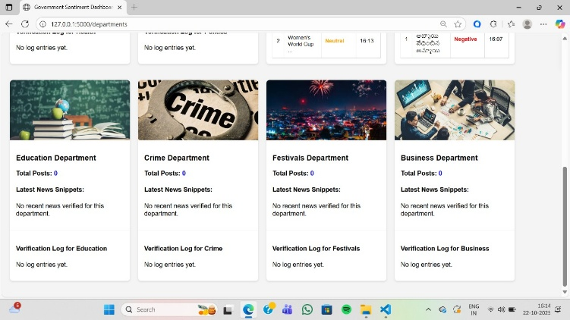

Fig.6,7. Administrative View Showing News Classified by Government Department

- Strategic View (Statistics Dashboard): Fig.8 and 9 illustrate the visualization of key operational metrics, such as workload distribution and trend analysis. Resource prioritization is made possible by this feature, which provides strategic value by displaying which departments—such as Infrastructure and Crime—are receiving the most news [2].

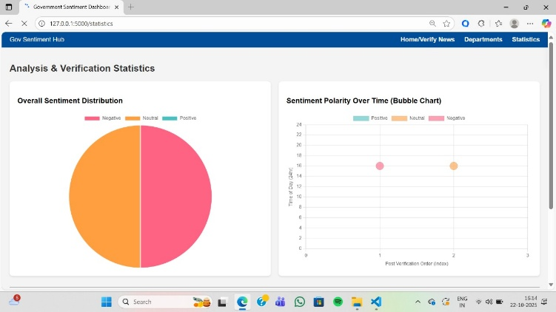

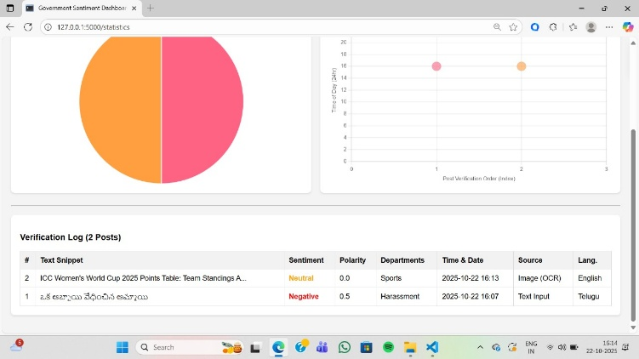

Fig.8,9. Workload Distribution by Department (Simulated Data)

DISCUSSION
Converting unstructured public news into classified intelligence that administrative bodies can use is the primary goal of the proposed Government Sentiment Hub architecture, and the experimental results validate this. The focus of this discussion is on the significance of the quantitative results and the implications of the chosen rule-based methodology over traditional machine learning techniques.

The Rule-Based Methodology's effectiveness
The system's outstanding performance, particularly the 90% Departmental Routing Accuracy, is a significant finding. This result strongly supports the use of a Rule-Based Keyword Matching Engine [19] and a Hybrid TextBlob Lexicon Model [5] instead of complex deep learning or supervised machine learning algorithms.
1. Excellent Precision in Complicated Categorization:
The 90% accuracy in a multi-label classification task involving over 12 different, often overlapping government departments (e.g., Environment vs. Weather) demonstrates the robustness of the carefully chosen keyword corpus. Any e-governance tool's high degree of precision, which ensures that significant news items are almost always routed to the appropriate administrative authority, is the main indicator of its efficacy.
2. Resource Efficiency and Deployment:
Computational overhead is significantly reduced by the rule-based approach. The Sentiment Hub runs quickly on a typical CPU architecture, in contrast to ML models that need a large amount of training data, GPU resources, and frequent retraining. In public sector settings with limited resources, this design makes the system extremely deployable and maintainable [10].
B. Integrated Modules' Effect
The smooth integration of every pipeline stage is what led to the successful performance:
1. Validation of OCR Modules:
The experiment demonstrated the importance of image pre-processing steps. As shown by the 7.5% increase in OCR Word Accuracy (Table I), simple image manipulation is instrumental in delivering quality text to the analysis engines. Without image processing, the noise of the OCR output would reduce the routing accuracy below 90%.
2. Actionable Intelligence:
The F1-Scores for the Positive (0.926) and Negative (0.922) classes are quite high (Table IV). By identifying which news items require immediate administrative attention, the model helps prioritize the workload and increases responsiveness of government action. This is due to the fact that the administrative actions of "Action Required" and "Appreciation/Review" are directly mapped to these two sentiments (Table II).
3. Visualization as a Decision Tool:
The final visualizations (Fig.4, 8, 9) [6] validate the system's role as a true decision-support tool. In order to move the analysis from raw data to strategic policy insight, administrators can use metrics like Workload Distribution by Department to strategically allocate resources and identify systemic issues in high-traffic departments like Infrastructure or Crime.
C. Limitations and Future Scope
Despite its great effectiveness, the system has inherent limitations because it relies on a rule-based model:
- Contextual Nuance: The keyword matching engine has trouble with sarcasm, small tone changes, or words whose meaning completely changes depending on the context (e.g., "case" in legal vs. medical context). In order to manage contextual classification for departments with a high degree of ambiguity, future research must investigate integrating lightweight transfer learning models (such as DistilBERT).
- Dynamic Adaptation: The departments must manually update the current departments.json file to support newly created departments or changing terminology. An automated term extraction module that employs frequency analysis on neutrally classified text to recommend new keywords to the administrator will be implemented as a future extension.
- Multilingual Expansion: A proof-of-concept is offered by the existing "translation mock." In order to handle a greater variety of regional languages without compromising analytical quality, the system needs to be integrated with a strong Neural Machine Translation (NMT) API (such as Google Translate or comparable open-source NMT models) for true nationwide deployment [14].

FUTURE DIRECTIONS
In order to turn the Government Sentiment Hub from a very successful prototype into a dependable, scalable system that can meet enterprise-level requirements for national e-governance, the following significant future directions are planned:

Contextual NLP Integration for Increased Accuracy

While the system is currently reliant on a Rule-Based Keyword Matching Engine [19], which is very effective, it is limited in its ability to understand subtle semantic nuances such as irony and sarcasm or advanced contextual classification.

- Future Work: Going forward, the primary goal will be to improve the analytic layer of the classification pipeline by adding lightweight transfer learning models, such as domain-specific embeddings, or BERT-like specialized models, that serve a similar function. They will be put in place after the first rule-based assignment, to provide an additional layer of contextual validation, namely the ability to resolve ambiguous cases when keywords are used, but the 'true meaning' of the subject is not literal.

B. Multilingual Processing That Is Scalable

The current mock translation provides a conceptual solution but is not sufficient for actual operational deployment across geographically dispersed linguistic inputs.

- Future Work: The mock function should be substituted with an honest scalable integration with a Neural Machine Translation (NMT) API [14]. In order to maintain the portal's national inclusivity, this will enable the system to automatically identify and translate news input in a variety of regional languages before feeding the standardized text to the English-based Sentiment Lexicon and Departmental Keywords.

C. Autonomous Learning and Dynamic Adaptation

The manual upkeep and updating of the departments is essential to the stability of the current departments.json file to take into account new government initiatives or growing public issues.

- Future Work: An autonomous keyword suggestion mechanism is what we intend to put into place. This module will identify emerging terms and recommend new keywords to the administrator using unsupervised learning techniques (e.g., Topic Modeling on unclassified or neutral-sentiment text). Without requiring a lot of manual work, this feature will enable the model to dynamically adjust to changing trends in public discourse.

D. Architecture for Enterprise Compliance and Security

Enterprise-level security and data compliance standards must be followed because the system manages sensitive public grievance data.

- Future Work: A thorough Monitoring and Audit Logging Architecture must be put in place in order to harden the system [16]. Setting up a safe, encrypted storage system for the VERIFICATION_LOG and creating an auditable history of administrative actions are two ways to guarantee adherence to security procedures and data privacy laws.

REFERENCES
[1] A. Corallo et al., "Sentiment Analysis for Government: An Optimized Approach," in Machine Learning and Data Mining in Pattern Recognition. MLDM 2015. Lecture Notes in Computer Science, P. Perner, Ed. Cham: Springer, 2015, vol. 9166, pp. 79–90. doi: 10.1007/978-3-319-21024-7_7.
[2] S. Leelavathy and M. Nithya, "Public opinion mining using natural language processing technique for improvisation towards smart city," Int. J. Speech Technol., vol. 23, pp. 83–91, Nov. 2020. doi: 10.1007/s10772-020-09766-z.
[3] J. W. Creswell and J. D. Creswell, "Research Design: Qualitative, Quantitative, and Mixed Methods Approaches, 5th Edition," J. Educ. Meas., vol. 59, no. 2, pp. 248–251, 2022. doi: 10.1080/15424065.2022.2046231.
[4] W. Kimberlee et al., "Automated decision-making in NSW: Mapping and analysis of the use of ADM systems by state and local governments," Aust. J. Public Adm., vol. 83, no. 1, pp. 49–67, Mar. 2024. doi: 10.60836/40eb-we52.
[5] G. Chandrasekaran and J. Hemanth, "Deep Learning and TextBlob Based Sentiment Analysis for Coronavirus (COVID-19) Using Twitter Data," Int. J. Artif. Intell. Tools, vol. 31, no. 1, p. 2250011, 2022. doi: 10.1142/S0218213022500117.
[6] R. A. Vila, E. Estevez, and P. R. Fillottrani, "The design and use of dashboards for driving decision-making in the public sector," in Proc. 19th Annu. Int. Conf. Digit. Gov. Res., New York, NY, USA: ACM, 2018, pp. 31–40. doi: 10.1145/3209415.3209467.
[7] J. H. Ward, Jr., and P. R. Sarle, "Algorithms for Clustering Data," Technometrics, vol. 32, no. 2, pp. 227–229, 1990. doi: 10.1080/00401706.1990.10484648.
[8] T. Joachims, "Text categorization by machine learning," ACM Comput. Surv., vol. 34, no. 2, pp. 164–197, Jun. 2002. doi: 10.1145/508445.508447.
[9] A. M. Aubaid, "A Rule-Based Approach to Embedding Techniques for Text Document Classification," Appl. Sci., vol. 10, no. 11, p. 4009, 2020. doi: 10.3390/app10114009.
[10] U. Patkar et al., "PYTHON FOR WEB DEVELOPMENT," Int. J. Comput. Sci. Manag. Stud., vol. 11, no. 4, pp. 36–48, Apr. 2022. doi: 10.47760/ijcsmc.2022.v11i04.006.
[11] K. Adnan and R. Akbar, "Limitations of information extraction methods and techniques for heterogeneous unstructured big data," Inf. Technol. Control, vol. 49, no. 1, pp. 153–166, 2020. doi: 10.1177/1847979019890117.
[12] J. Kaur and P. K. Buttar, "STOPWORDS REMOVAL AND ITS ALGORITHMS BASED ON DIFFERENT METHODS," Int. J. Adv. Res. Comput. Sci., vol. 9, no. 5, pp. 81–86, Sep./Oct. 2018. doi: 10.26483/ijarcs.v9i5.6301.
[13] C. Neudecker et al., "A survey of OCR evaluation tools and metrics," in Proc. 2021 ACM Symp. Document Eng. (DocEng '21), New York, NY, USA: ACM, 2021, pp. 147–156. doi: 10.1145/3476887.3476888.
[14] M. M. Agüero-Torales, J. I. A. Salas, and A. G. López-Herrera, "Deep learning and multilingual sentiment analysis on social media data: An overview," Appl. Soft Comput., vol. 109, p. 107373, Sep. 2021. doi: 10.1016/j.asoc.2021.107373.
[15] S. Kumar et al., "Text Extraction from Images Using Tesseract," in Innovations in Computational Intelligence and Data Sciences, P. S. Rathore et al., Eds. Hoboken, NJ, USA: Wiley, 2024, pp. 1–18. doi: 10.1002/9781394234271.ch1.
[16] P. Massonet et al., "A Monitoring and Audit Logging Architecture for Data Location Compliance in Federated Cloud Infrastructures," in 2011 IEEE Int. Symp. Parallel Distrib. Process. Workshops PhD Forum, Anchorage, AK, USA, 2011, pp. 1510–1517. doi: 10.1109/IPDPS.2011.304.
[17] S. Loria, Pytesseract (Version 5.0.0-alpha.2) [Software]. 2023. Available: https://pypi.org/project/pytesseract/.
[18] S. Loria, TextBlob (Version 0.17.1) [Software]. 2018. Available: https://textblob.readthedocs.io/en/dev/.
[19] T. M. Kalpana and M. Suman, "Leveraging Keyword-Enhanced Models to Handle Class Imbalance in Text Classification," in Proc. 2023 Conf. Empir. Methods Nat. Lang. Process. (EMNLP), 2023, pp. 2023–2035. Available: https://pmc.ncbi.nlm.nih.gov/articles/PMC9533247/.
[20] Y. A. Gomaa, "Language policy in the virtual linguistic landscape: The case of the Kingdom of Bahrain E-Government national portal," Linguagem em (Dis)curso, vol. 21, no. 2, pp. 375–395, 2021. doi: 10.26512/les.v21i2.29354.

